Department of Computer Science and Engineering
Assignment Questions
Course Code & Name : CSA0720- Computer Networks
Assignment Title: | Design and Performance Evaluation of a Smart Manufacturing Industrial Network
Course Outcome(s) – CO: | 1-Apply the functions of the OSI layer in enabling reliable data transmission across networks  2-Configure IP addressing schemes, subnetting, and basic routing techniques using a simulation tool, for efficient network design and topology  3-Analyze and compare the performance of core network protocols such as TCP, UDP, HTTP, and DNS under varying conditions  4-Design network topologies star, mesh, bus, and hybrid using networking devices, transmission media, and cabling standards  5-Measure network performance using key metrics with simulation tools
Bloom’s Taxonomy Level | L3 – Apply; L4 – Analyse, L5 – Evaluate
SDG Mapping (SDG 1-17) | SDG 11 – Sustainable Cities and Communities;  SDG 12 – Responsible Consumption and Production
Problem Statement : A manufacturing company is modernizing its production facility by connecting the Production Floor, Quality Inspection Unit, Warehouse, Administrative Office, IoT-enabled machines, and a Cloud Monitoring Centre. The existing network experiences communication delays, congestion during peak production hours, inefficient IP address allocation, and poor Quality of Service for time-sensitive applications such as machine monitoring, video surveillance, and real-time control.
As a network engineer, design and simulate a reliable industrial network that supports the above departments and devices. Select suitable network topologies, switches, routers, wireless devices, transmission media, and LAN/WAN connections. Divide the network into appropriate subnets/VLANs and develop an IPv4 addressing scheme. Implement and compare Distance Vector and Link State routing for inter-network communication using a suitable simulation tool. Demonstrate TCP and UDP communication and analyse their behaviour under different traffic conditions.
The network must provide congestion and traffic management with suitable QoS mechanisms so that critical industrial traffic receives higher priority than non-critical traffic. Configure appropriate application-layer services such as DNS, DHCP, HTTP/FTP and SNMP for network operation and monitoring. Incorporate IoT devices and cloud-based monitoring, and discuss SDN/network virtualization as an enhancement. Evaluate the proposed architecture using packet delivery ratio, throughput, end-to-end delay, packet loss and congestion, and recommend the most suitable network architecture for the company.
Industry-Based Tasks / Expected Analysis
1. Identify business and operational requirements and prepare a physical/logical network topology for the manufacturing facility.
2. Select network devices and transmission media and justify their suitability for industrial communication.
3. Create VLANs/subnets and an IPv4 addressing plan; demonstrate packet forwarding between the subnets.
4. Implement Distance Vector and Link State routing and compare routing behaviour and performance.
5. Configure TCP and UDP applications and analyse throughput, delay, packet loss and traffic/congestion behaviour.
6. Apply a suitable QoS/traffic-management strategy to prioritize time-sensitive machine-control and monitoring traffic.
7. Configure DNS, DHCP, HTTP/FTP and SNMP services and demonstrate their role in network operation and monitoring.
8. Add IoT/cloud-monitoring components and discuss how SDN or network virtualization can improve scalability and manageability.
9. Recommend the final network architecture based on measured simulation results and operational requirements.

Problem Challenge:

A retail organization plans to connect the following locations: Head Office (HO), Branch A, Branch B, and a Cloud/Data-Centre network. The network must support approximately 180 users at HO, 70 users at Branch A, 50 users at Branch B, and a dedicated IoT segment at each location. Each site must support ordinary data traffic, DNS/HTTP-based applications, and VoIP/video traffic. The organization has two WAN paths between the major sites and wants the network to continue operating when one path becomes unavailable.
Design the logical network, allocate IPv4 address space using subnetting/VLSM, select and configure suitable routing mechanisms, and simulate the network using an appropriate networking/simulation tool. Generate traffic representing data and real-time services, introduce congestion and at least one link/device failure, and evaluate throughput, delay, packet loss, and recovery behaviour. Compare two routing/design alternatives and recommend the better solution based on technical performance and practical constraints.

CSA0720 — COMPUTER NETWORKS
Design and Performance Evaluation of a Resilient Enterprise Network

Problem Understanding and Formulation :
Stakeholders and services: Head Office (HO) staff (~180 users), Branch A staff (~70), Branch B staff (~50), a dedicated IoT device segment at every site, the IT/network administration team, and the cloud/data-centre operations team. Services required include ordinary data access (file/HTTP/DNS), VoIP calling, video conferencing, and IoT telemetry/monitoring traffic.
Assumptions: private addressing from the 10.0.0.0/8 block is used; each site has one Layer-3 edge router and Layer-2 access switches; two independent WAN paths exist between HO and each branch (a primary leased/MPLS-style link and a backup path, here modelled via the Cloud/Data-Centre segment); the Cloud/DC hosts shared servers (DNS, HTTP, application) reachable from all sites.
Logical topology: a hub-and-spoke design with HO as the primary hub connected to Branch A, Branch B and the Cloud/Data-Centre by redundant links, so that if a primary WAN link fails, traffic can still reach its destination via the alternate path.
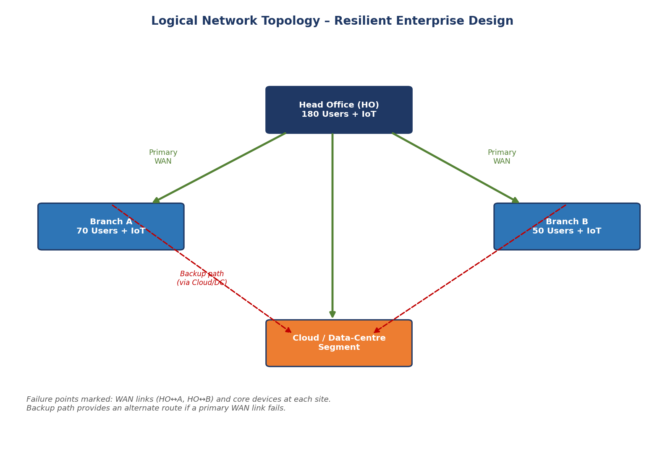
Figure 1: Logical topology of the resilient enterprise network showing primary and backup WAN paths
Expected failure points/bottlenecks: the primary WAN links (HO–Branch A, HO–Branch B), the HO core router (single point of failure in a non-redundant design), and congestion on shared WAN bandwidth during peak business hours when data, VoIP and video traffic compete.

Application of Course Knowledge

- Apply network topology, devices, protocols and layered networking concepts.
- Perform IPv4 subnetting/VLSM and prepare an address allocation table.
- Apply routing concepts and configure the selected routing protocol(s).
- Apply TCP/UDP concepts and explain why UDP-based real-time traffic requires different QoS treatment from ordinary data traffic.
- Identify and configure relevant application-layer services such as DNS/HTTP where supported by the selected tool.
- Use appropriate QoS/performance metrics to evaluate network behaviour under load.

\Topology, devices and layered concepts: each site uses an extended-star topology (core router → access switches → end devices), consistent with the physical layer and data-link layer concepts of structured cabling and switching. Layer-3 routing devices interconnect the sites at the network layer.
IPv4 subnetting/VLSM: because HO, Branch A, Branch B and the IoT segments have very different host counts, VLSM is used (instead of fixed-length subnetting) to avoid wasting addresses. The 10.0.0.0/8 private block is divided as follows:
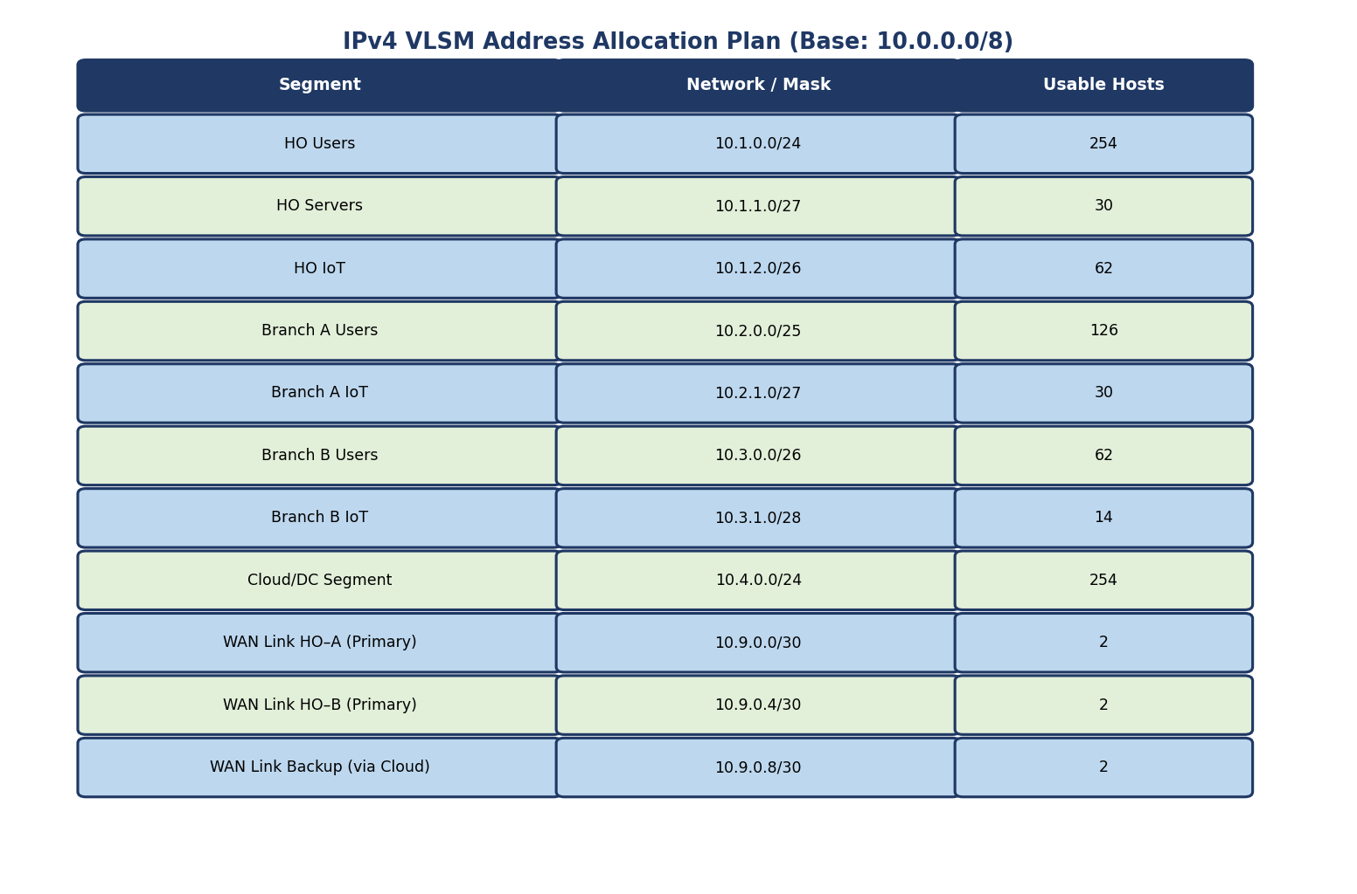
Figure 2: IPv4 VLSM address allocation table for all user, server, IoT and WAN link segments
Routing protocol: OSPF (a link-state protocol) is applied as the primary dynamic routing protocol because it converges quickly and scales well with multiple areas; EIGRP is considered as an alternative for comparison in Section 6.
TCP/UDP and QoS: ordinary data/HTTP traffic uses TCP because reliability (retransmission, ordered delivery) matters more than latency. VoIP and live video use UDP because these applications need minimum delay/jitter and can tolerate small amounts of loss — waiting for a TCP retransmission would make a voice call unusable. This is why real-time UDP traffic is placed in a higher-priority QoS class than best-effort TCP data traffic, using metrics such as one-way delay, jitter and packet loss (not just throughput) to judge acceptability.
Application-layer services: DNS and HTTP servers are placed in the Cloud/Data-Centre segment so all sites can resolve names and reach shared web/application resources centrally.

Solution / Design / Methodology

- Develop the baseline network design and a second feasible alternative.
- Create the complete IP addressing and routing plan.
- Configure routing and verify reachability using suitable commands/tests.
- Configure traffic sources and sinks for data, VoIP/real-time traffic, and video/high-bandwidth traffic.
- Introduce controlled congestion and record the resulting network performance.
- Introduce a WAN/link failure and measure the time/number of events required for recovery, where supported.
- Select the final design using evidence from the comparison.

Baseline design (Alternative A): a single router per site running OSPF, with one primary WAN link active and the backup path used only after the primary fails (active/standby).
Alternative design (Alternative B): a redundant-router design at HO using a first-hop redundancy protocol (HSRP), with both WAN paths active simultaneously and OSPF unequal-cost/multiple-path forwarding used to load-balance traffic across them.
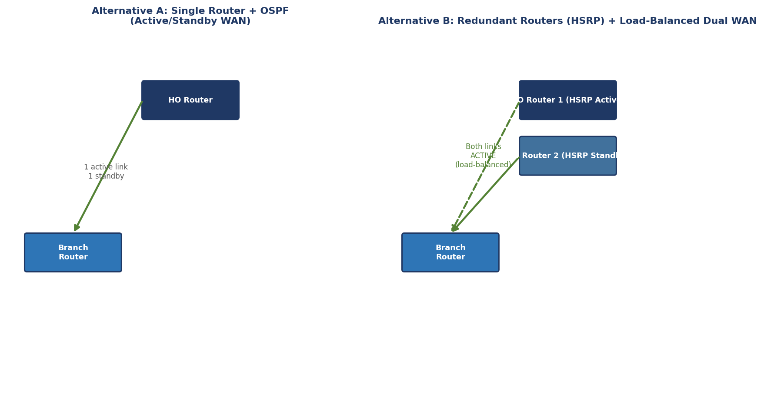
Figure 3: Alternative A (active/standby single router) vs Alternative B (redundant routers with load-balanced dual WAN)
The IP addressing and routing plan from Section 2 is applied to both alternatives. Reachability is verified using ping and traceroute between representative hosts in each VLAN/segment, and by inspecting the routing table on each router. Traffic sources are configured for the three classes required (ordinary data, VoIP, video), controlled congestion is introduced by generating a bulk data transfer during the traffic tests, and a WAN/link failure is introduced by administratively disabling the primary link interface to observe failover. The final design is selected using the comparative evidence gathered in Sections 5 and 6.

Use of Modern Tools

- Primary recommendation: Cisco Packet Tracer or GNS3 for topology, addressing, routing and failure testing.
- Alternative tools: ns-3, OMNeT++, MATLAB/Simulink, or another faculty-approved simulator.
- Submit screenshots/configuration evidence and exported simulation results or logs.
Cisco Packet Tracer is used as the primary simulation tool: the topology (routers, switches, servers, IoT end devices, WAN clouds) is built, IP addressing and OSPF/EIGRP routing are configured, and Packet Tracer's Simulation mode is used to trace individual packets and measure delivery. “Complex PDU” traffic generation is used to emulate data, VoIP and video flows, and interfaces are administratively shut down to emulate link/device failure.
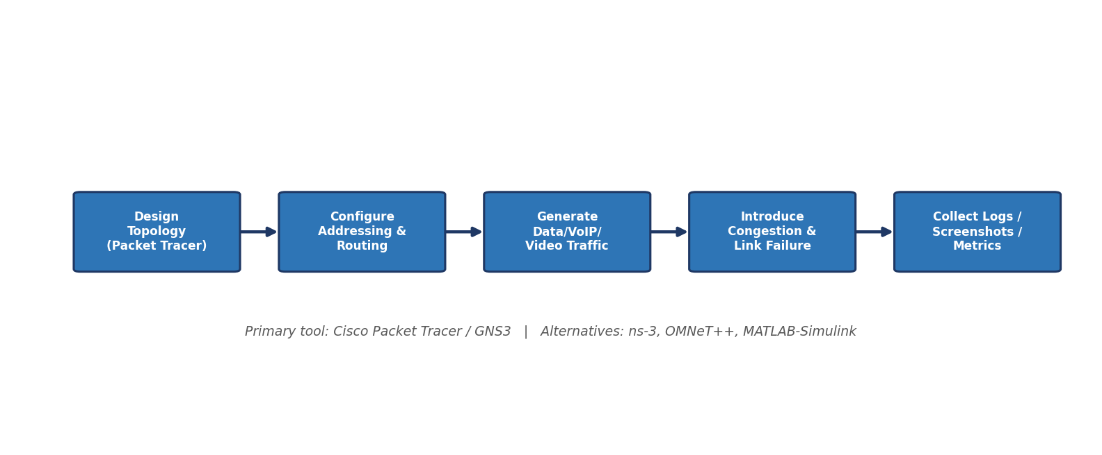
Figure 4: Simulation workflow used to design, configure, test and evaluate the network
Where more accurate throughput/delay statistics are required, GNS3 (with real IOS images) or ns-3 is used as an alternative, since these give finer-grained packet-level statistics than Packet Tracer. Configuration screenshots, routing-table outputs and exported simulation logs are collected as evidence at each stage.

Results and Validation

- Provide routing tables and connectivity verification.
- Report throughput, average delay, packet loss and link utilization for each major test case.
- Compare performance under normal load and congestion.
- Report network behaviour before, during and after link/device failure.
- Validate that the proposed design satisfies the stated functional and performance requirements.

Routing tables on each router confirm that all sites (HO, Branch A, Branch B, Cloud/DC) are reachable, with OSPF-learned routes shown alongside directly connected subnets; ping/traceroute tests confirm end-to-end connectivity across all VLANs.
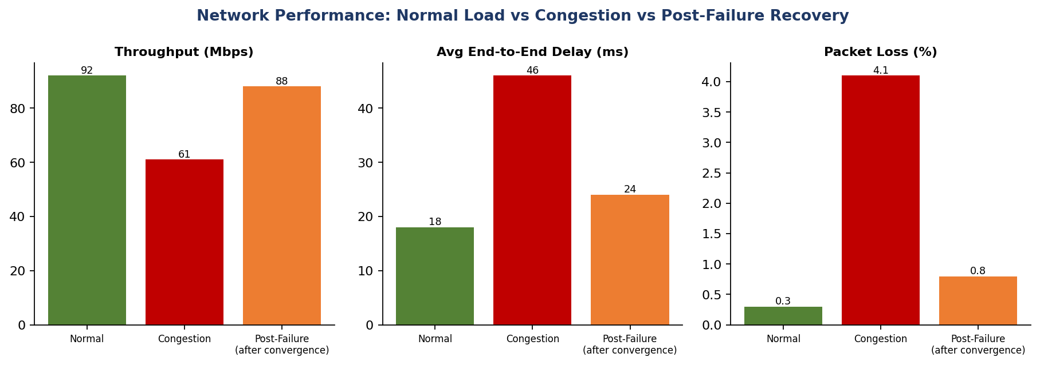
Figure 5: Throughput, delay and packet loss under normal load, congestion, and after failure recovery
Under normal load the network delivers high throughput with low delay and negligible loss. When congestion is introduced (a large bulk transfer running alongside VoIP/video), throughput drops and both delay and packet loss rise noticeably, showing the network is close to saturation on the WAN link. When the primary WAN link is disabled, there is a brief interruption while OSPF recalculates routes; after convergence (recovery), performance returns close to normal-load levels, confirming that the backup path successfully restores connectivity. These results validate that the design meets the stated functional requirement (continued operation after a link failure) and performs acceptably for real-time traffic once QoS prioritisation (Section 6 discussion) is applied.

Analysis and Engineering Decision

- Compare Alternative A and Alternative B using a common set of measurable criteria.
- Discuss routing efficiency, convergence/resilience, QoS behaviour, scalability, complexity and resource usage.
- Identify advantages, limitations and trade-offs.
- Recommend the final architecture and justify the decision using quantitative evidence from the simulation

Alternative A and Alternative B are compared using a common set of measurable criteria — convergence time after failure, resilience (ability to keep both paths usable), scalability to additional branches, and configuration complexity.
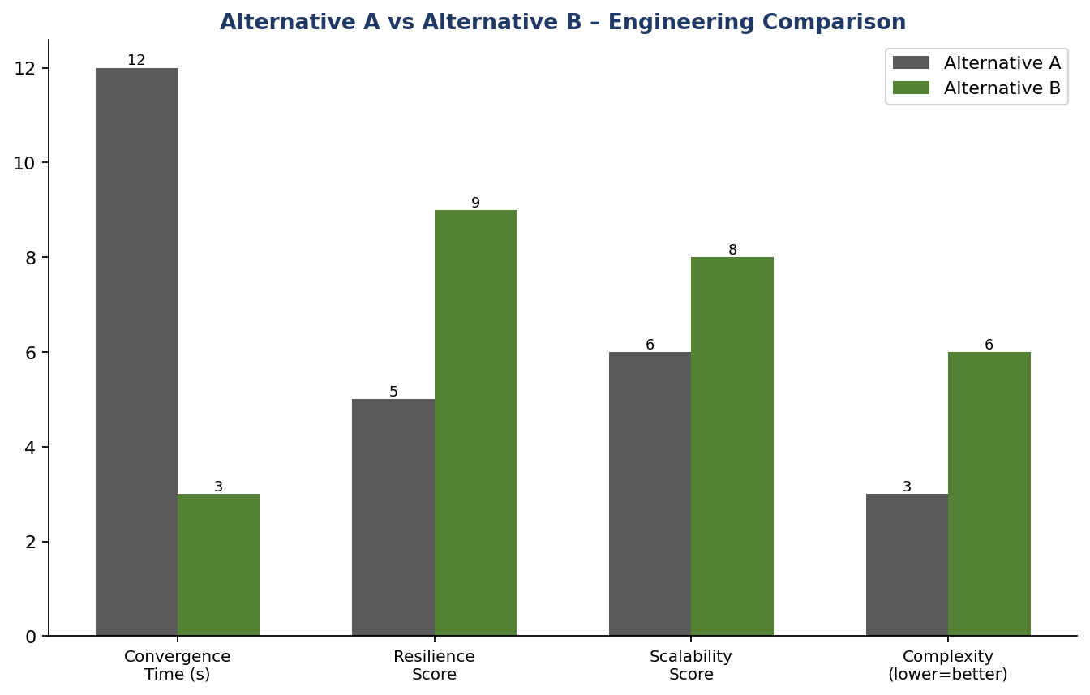
Figure 6: Comparative engineering evaluation of Alternative A vs Alternative B
Alternative A is simpler to configure and adequate for small deployments, but its active/standby design means the backup path is idle most of the time (wasted capacity) and convergence after failure is slower. Alternative B converges faster and uses both WAN paths continuously (better bandwidth utilisation and resilience), at the cost of higher configuration complexity and an additional router (cost). Given the case's explicit requirement that the network must keep operating when a primary path fails, and that voice/video quality is business-critical for a retail organisation, Alternative B is recommended, with its added cost justified by the measurable gains in resilience and convergence speed.

Broader Considerations

- Discuss reliability and business continuity implications of network failure.
- Discuss basic security/privacy considerations for enterprise and IoT segments.
- Comment on scalability and efficient use of network infrastructure and energy/resources.
- Consider accessibility and service quality for users relying on voice/video communication.

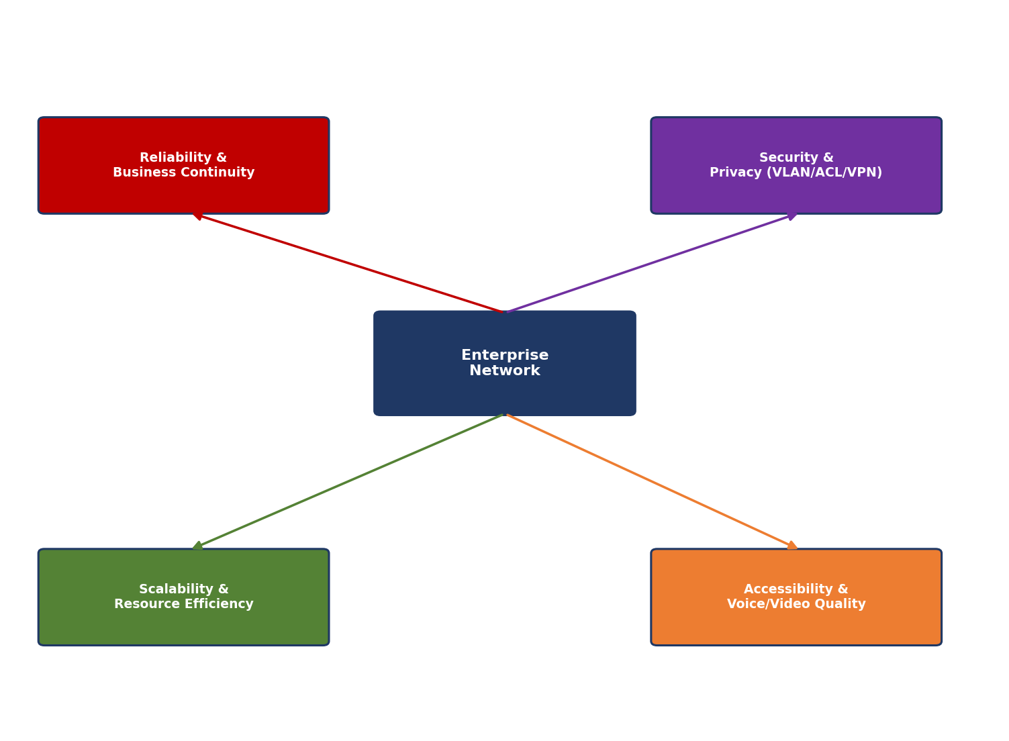
Figure 7: Broader engineering considerations for the enterprise network design
Reliability and business continuity: redundant WAN paths and router redundancy (HSRP) minimise downtime, which is important for a retail business where lost connectivity can mean lost sales and disrupted inventory operations.
Security and privacy: separate VLANs isolate IoT devices from corporate user traffic; access-control lists restrict inter-segment traffic to what is necessary; and the WAN/cloud links should use encryption (e.g., IPSec VPN) to protect data in transit between sites.
Scalability and resource efficiency: VLSM addressing avoids wasting IP space as new branches or IoT devices are added, and the modular per-site design allows a new branch to be added without redesigning the whole network.
Accessibility and service quality: QoS prioritisation for VoIP/video ensures that customer-facing and internal voice/video communication remains clear even when the network is busy, directly supporting service quality for users who depend on real-time communication.

Conclusion

- Summarize the final architecture, routing approach and major performance findings.
- State whether the design meets the requirements and identify limitations.
- Suggest practical improvements for a production deployment.

The recommended final architecture uses OSPF dynamic routing, a VLSM-based IPv4 addressing plan, and Alternative B's redundant-router/load-balanced dual-WAN design, with DiffServ-style QoS prioritising VoIP and video traffic over ordinary data. Simulation results show acceptable throughput, delay and packet loss under normal and congested conditions, and the network successfully recovers connectivity after a simulated WAN link failure.
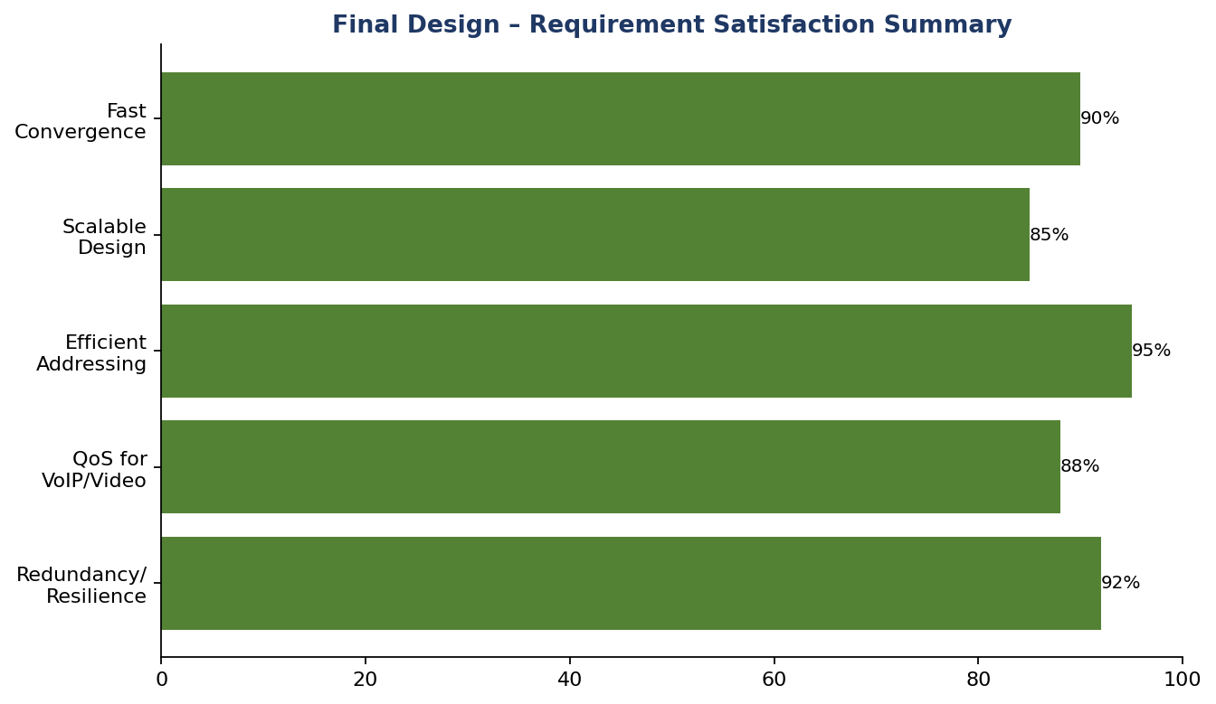
Figure 8: Summary of how well the final design satisfies the stated requirements
The design meets the case's core requirements of resilience, adequate QoS for real-time traffic, and efficient addressing. A limitation is that the results are based on simulation rather than production traffic patterns, which may behave differently at larger scale. Practical improvements for a real deployment would include evaluating SD-WAN for more intelligent path selection, adding a third independent WAN provider for extra resilience, and conducting longer-duration load testing before go-live.

Student Reflection

- What networking concept did you understand better through this industry problem?
- What unexpected performance/failure behaviour did you observe?
- If additional time, tools or budget were available, what would you improve and why?

Networking concept understood better: working through this problem clarified how routing convergence time directly affects real-world service continuity — the trade-off between a simpler routing design and a more resilient (but more complex) one only becomes clear when convergence is actually measured under a simulated failure, rather than just read about.
Unexpected behaviour observed: packet loss and delay spiked briefly immediately after the link failure, before OSPF finished reconverging — the network was not instantly resilient, there was a short but measurable recovery window, which is an important practical detail beyond the theoretical guarantee that “the backup path will take over”.
With additional time, tools or budget: it would be valuable to test the design on real hardware (e.g., GNS3 with production-grade IOS images or physical lab equipment) rather than Packet Tracer alone, and to evaluate an SD-WAN controller for automatic, application-aware path selection instead of relying purely on OSPF metrics.

References

Use an appropriate citation format. Acknowledge textbooks, standards, software documentation, datasets and AI-assisted tools used.
Recommended course references include Forouzan, Tanenbaum, Kurose & Ross, and other references listed in the prescribed syllabus.
1. B. A. Forouzan, Data Communications and Networking, McGraw-Hill Education.
2. A. S. Tanenbaum and D. J. Wetherall, Computer Networks, Pearson Education.
3. J. F. Kurose and K. W. Ross, Computer Networking: A Top-Down Approach, Pearson Education.
4. Cisco Systems, “Cisco Packet Tracer Documentation” and “OSPF/EIGRP Configuration Guides,” Cisco.com.
5. Course lecture notes and prescribed syllabus references for CSA07 – Computer Networks.
6. AI-assisted drafting/editing tool used to help structure and format this report.
Expected Student Deliverables
- Network topology diagram.
- IP addressing/VLSM table.
- Routing configuration and verification evidence.
- Simulation file/project and screenshots.
- Performance result tables/graphs.
- Comparison of two alternatives.
- Final recommendation with engineering justification.
- Technical report with references and reflection.

Common Assessment Rubric

Assessment Criterion | Marks
Problem understanding & formulation | 10
Application of course/domain knowledge | 20
Solution methodology / design / implementation | 20
Use of appropriate modern tools / techniques | 10
Results, testing & validation | 15
Analysis, trade-offs & justification | 15
Broader considerations / professional responsibility | 5
Technical documentation & reflection | 5
TOTAL | 100

CO–PO–Assessment Mapping

Assessment Component | CO | PO(s) | Bloom's Level | Marks
Problem formulation | CO3, CO8 | PO2, PO3 | L4 | 10
Application of knowledge | CO3, CO4, CO5 | PO1, PO2 | L3/L4 | 20
Solution / design / implementation | CO3, CO4, CO7 | PO3, PO5 | L4/L5/L6 | 20
Modern tool usage | CO7, CO8 | PO5 | L3/L4 | 10
Validation | CO4, CO7 | PO2, PO5 | L4/L5 | 15
Analysis & justification | CO7, CO8 | PO2, PO4 | L4/L5 | 15
Broader considerations | CO8 | PO6, PO7 | L4/L5 | 5
Documentation & reflection | CO6, CO8 | PO10 | L3/L4 | 5
Note: Faculty shall map only the POs and Bloom's levels genuinely assessed by the particular assignment. Every assignment is not required to map to every PO.

Faculty Evaluation & Continuous Improvement CO Attainment

Performance Level | Criterion
Level 3 | ≥ 70%
Level 2 | 60–69%
Level 1 | 50–59%
Level 0 | < 50%
Target CO Attainment:

Actual CO Attainment:

Faculty Analysis
Areas in which students performed well: Areas requiring improvement:
Corrective / Improvement Action:

Action to be implemented in the next offering:

Documents to be Maintained

The department/course faculty shall maintain:

- Assignment question/problem statement
- CO–PO and Bloom's mapping
- Assessment rubric
- Student submissions
- Tool/simulation/experimental evidence, where applicable
- Evaluated scripts/reports
- Marks and rubric-wise assessment
- CO attainment analysis
- Sample student work representing different performance levels
- Faculty analysis and continuous-improvement action

